THE REFUGEES AND THE EUROPEAN SOCIETIES
CASE STUDY – BULGARIA
Yordan Bozhilov
Without a doubt, the European Union has run into one of its most complex and seemingly unsurmountable challenges, namely the current unprecedented level of immigration. The EU, as a highly developed and value-based entity, has turned into a primary migratory destination. Political and social upheaval in the Middle East and Africa, caused by events, such as the Arab Spring and the Syrian Civil War, has triggered a mass influx of migrants. The majority of the immigrants are of Afghan, Syrian or Iraqi origin. Moreover, the European Union is currently facing a mixed migration flows made up of refugees and economic migrants. Furthermore, the dislodgement of the security, political and social systems in the aforementioned regions is expected to prompt new waves of migration.
More than 750,000 migrants are estimated to have arrived by sea so far this year, according to the International Organization for Migration (IOM), but exact numbers are unclear as some may have passed through borders undetected. In addition, the phenomenon of immigration, in spite of being historically recurrent, has stirred up fear among people, thus threatening to parcel out the social cohesiveness of the European societies. The fact that immigrants want to settle in Europe permanently has elicited concerns among citizens about the effects of their presence.

Refugees in Bulgaria: trends and analyses
The number of people seeking international protection in the EU has been growing continually in 2015 and Bulgaria has not remained apart from this process. During the last years, with the continuous growth of the persons seeking protection in Bulgaria, a considerable change can be observed in their profile, as compared to the people, who sought protection before the beginning of the “refugee pressure” against this country - in the autumn of 2013.
In 2015, the number of foreign persons seeking protection reached almost 20,000, but the number of illegal migrants which have crossed the Bulgarian border remains unknown.
Compared to other states on the Balkans, the number of migrants to Bulgaria remains relatively small. Until now migrants try to avoid Bulgaria. There are several explanations to this fact.
First of all, Bulgaria is not the desired destination for migrants. Although the country is a member of the EU, it cannot provide desired social benefits for migrants and work opportunities. This is also visible from the survey, results of which are shown below. Bulgaria is the poorest European country and migrants shows no interest to stay in it.
The second factor, closely related with the first one, are measure of the Bulgarian government to protect borders and to register all migrants which enter the Bulgarian territory. They do not wish to be registered here because of the opportunity to be later returned back to “their First Country of Registration”. The final destination of the refugees are the countries providing generous social aid systems and work opportunities, such as Germany, Sweden, etc. The prospect to remain in Bulgaria and live here makes migrants to avoid the country and search for other ways towards their final destination.
The persons seeking international protection in Bulgaria mainly come from Syria, Afghanistan, and Iraq – the citizens of these three countries account for 93.4% of all migrants /statistical data is provided by the Bulgarian State Agency of Refugees/. For this same period, statistics show that the biggest share according to the age factor belongs to persons in the 18 to 34 years – 61.4%, and to people capable to work – 73%. The gender factor shows 79.3% men and 20.7% women. Since the year of 2013, about 30% of the people are kids, and 39% of the kids are not attended by elders. For this same period, the persons with no education at all are 21%, and the persons with elementary or primary education – 55%.
At the time being there is a significant growth in the number of Iraqi citizens, growing more than 4 times in number compared to the year of 2014; they account for 27% of all seeking protection for the last 9-month period.
The number of children has been in drastic rise since the beginning of the “refugee crisis”. 188 children in 2012; 2,087 in 2013; 2,417 in 2014; 4,024 for the first three quarters of 2015.
Since the year of 2013, about 30% of the persons seeking protection are kids; the girls to boys correlation remains the same – 1:2.
The gender distribution remains the same for the last years. The male gender accounts for 78%, on the average, and the female – for 22%.
For the period 01.01.2015 – 31.10.2015, statistics shows that, depending on age, the highest percentage belongs to the persons between 18 and 34 years – 61%; the percentage of people aged over 65 is ignorable. The people capable to work are 73%.
The data for the last four years concerning the education status show a significant change of the percentage rate between the different educational degrees. For the years after the beginning of the “refugee wave’’, the percentage of people with university or college education dropped more than twice, compared to the rest of the categories. The statistics say that for the last two years the persons with no education average 21% while the low-educated people with elementary or primary education are 55%. After the beginning of the year of 2014, the persons seeking protection designating university or college educations as their background, are only 7%, and just a small part of them are able to present a document to certify it. From the beginning of the year of 2013, and until October 2015, the number of non-educated and low-educated people rates at 78% of all persons seeking protection.
In 2014 and the first ten months of 2015, there is an abrupt rise in the number of unattended children seeking protection, as compared to the previous years. In 2014 almost 39% of the children seeking protection were unattended. The biggest share in this vulnerable category were Afghani children – 74%, amongst which 66 of minor age, and 630 not reached full-age. Almost half of them were at the age of 16-17 years.
Compared to the previous year, since the beginning of 2015, the number of children originating from Iraq grew more than ten times. Also, considerable drop is noticed in the number of Afghani children but rise in the number of children from Syria.
Based on the above data, the following general profile of the “Refugee in Bulgaria” may be outlined:
• The people seeking protection in Bulgaria mainly come from the Middle East Region – Syria, Iraq, and Afghanistan.
• Related to gender, a slow growth is observed in the number of males. The number of males with no families is large – over 40%.
• The share of children is relatively high – approximately 30%. The number of unattended children is in a state of drastic rise.
• The people capable to work are 73%.
• The share of people with no education ad with a low education – elementary or secondary – is very high – 78%.
It is clear that in spite of the fact that the number of people wishing to stay in Bulgaria is relatively small, there is a need that the country builds a capacity for integration of the migrants.
Despite the big number of refugees in Bulgaria no integration program exists at present. Bulgarian government has to put more efforts in this regard and to develop and adopt integration strategies and policies.

Refugees in Bulgaria and their aptitudes for integration in European societies.
In order to analyze the integration aptitudes of the refugees, an assessment has been conducted with foreigners residing in Bulgaria in November, 2015. The assessment was made in the “Voenna Rampa” Refugee Center in Sofia, by means of an inquiry. With the presence of a representative from the Bulgarian Refugee Association around 40 refugees above the age of 18 willingly took part in the survey, the number of women was very limited compared to the men. Mostly Syrian nationals, with a few Iraqis.
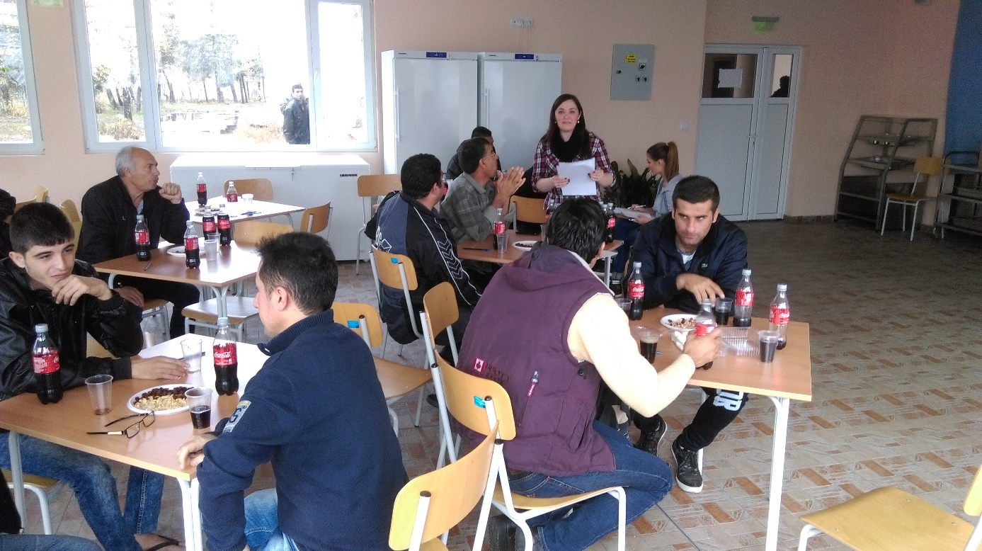
During the interviews
Most of them came from poor families and with very low education, mainly primary school.
None of them could speak Bulgarian, English or any foreign language, some of the Kurdish people among them can not even speak Arabic well, as they finished only primary school. That is why they needed some help in translating the survey form. However, the others filled the form by themselves.
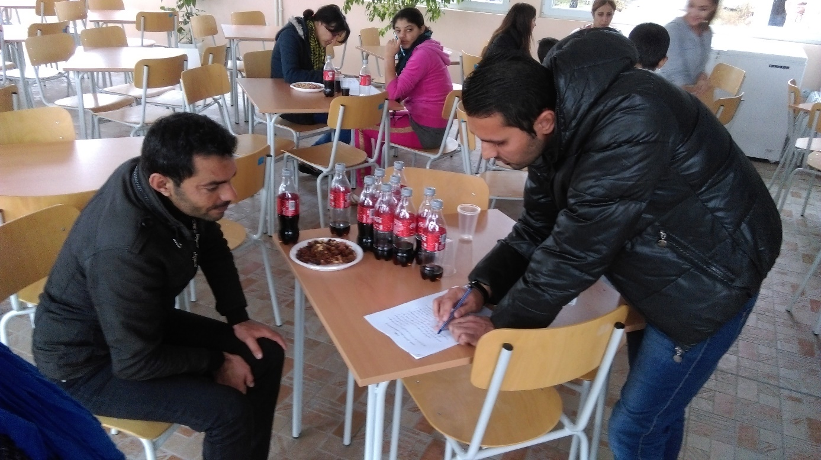
Some of the refugees cannot read and write
Also, an inquiry has been developed for establishment of the attitudes of the Bulgarian citizens concerning the integration of foreigners; this inquiry was only online, open for people willing to answer it.
The aptitude quoted only shows the timely mood of the public. It cannot be considered an absolute criterion to guarantee that the foreigners could find their place in the Bulgarian (or other European) society.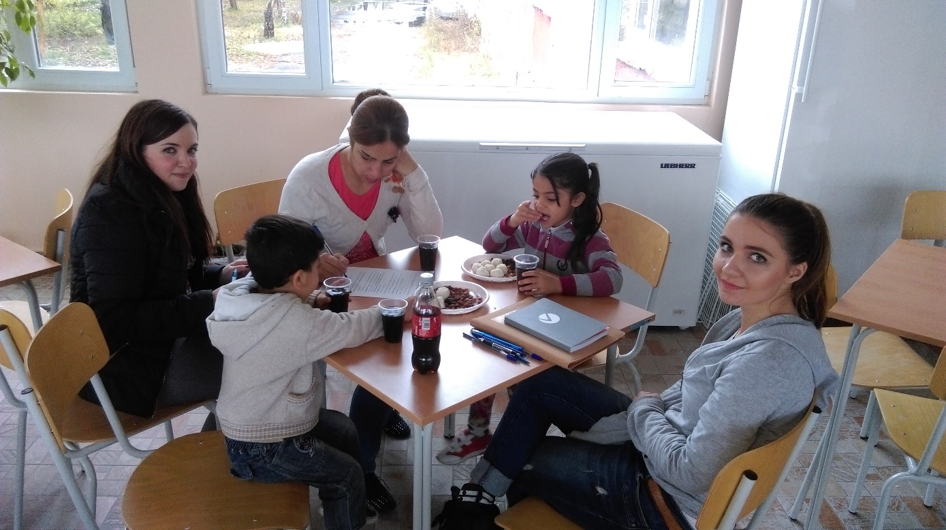
Filling in the questionnaires
The only way of toning down the tension within states and slurring over the differences in perception between immigrants and host societies is to devise strategies for the immigrants’ integration. However, the formulation and implementation of successful integration policies, at national and European level, requires an understanding of the immigrants’ attitudes towards migration in general and host societies in particular. One way of gaining such an invaluable insight is to gather primary data by carrying out a questionnaire and examine the opinions of the immigrants who are currently residing in Bulgaria. Hopefully, the accumulation of accurate data would help policy decision-makers, academic scholars and practitioners propound various integration policies.

Theoretical model of the study
With regard to the theoretical framework, the questionnaire is based on the so-called Zaragoza Indicators of Immigrant Integration. The indicators are the outcome of a pilot study aimed at evaluating the EU member states’ integration policies, taking into account the different national contexts and the diversity of migrant communities. Not only have the Zaragoza Indicators been approved by the European Commission, but they also have been used as a research method by European governmental agencies, academic institutions and non-governmental organizations since their first consolidation in 2010. The Zaragoza Indicators fall into five separate policy areas - employment, education, social inclusion, active citizenship and “welcoming society”. As a result, the proposed questionnaire is composed of questions which are related to the abovementioned indexes.
The first set of questions focuses on the composition of the immigrant communities. Consequently, we pay heed to the immigrants’ demographic characteristics such as gender, age, country of birth and marital status. Immigrant groups have become more heterogeneous and receiving societies themselves have also been incorporating more and different nationalities. In fact, immigration has warranted a debate about the societal security of the European states. Moreover, it is widely accepted that societal unity is contingent on the boundary between those who are “like us” and those who are “not like us”. Therefore, the demographic composition of the immigrant communities has turned into an indispensable point of reference for the formulation of integration policies.
Another set of questions puts an emphasis on the employment indicators, such as employment rate, over-qualification and activity rate. Moreover, we have afforded importance to the immigrants’ willingness to work, to the criteria for choosing a job or to the appeal of social benefits. Employment is a key variable when measuring integration. Therefore, we need to acquire a deeper understanding of the immigrants’ claims to basic economic participation and security. The nature of the states’ labour markets and their levels of social protection can impinge on the movement of immigrant groups within the European Union.
The subsequent group of questions accentuates the significance of education as a mechanism of integration. The questionnaire touches upon the immigrants’ level of education, the propensity for learning the language of the host society, the access to educational systems, etc. We consider education a variable of paramount importance. Perhaps, education is the most comprehensive way of socializing immigrants through the acquisition of the norms and values to which all the members of a society subscribe. Political failures in the educational area will have a long-term impact on societies. The lack of intra-group communication might lead to alienation between communities. Furthermore, the consequences of social estrangement will be difficult to stave off since this phenomenon perpetuates itself through generations. Consequently, we need to analyse in detail the immigrants’ attitudes toward education and training.
The next set of questions revolves around the relevance of social inclusion. It is a proactive approach by nature because it entails governmental or non-governmental activities, whose purpose is to foster favourable conditions for the immigrants’ inclusion, such as health status, adequate income or safe housing. Therefore, the questionnaire features questions concerning the immigrants’ opinion about the sources of the expected income, their willingness to settle down by acquiring a property, and so forth. We are of the opinion that property ownership constitutes a successful form of membership in a society because it provides immigrants with the opportunity to interact with the host society on a daily basis. In turn, this situation is highly likely to decrease the social distance between newcomers and receiving societies. In that vein, the study of the immigrants’ attitudes toward scenarios, involving a constant interpersonal and intercultural communication is a prerequisite for the formulation of successful integration policies.
Last but not least, the questionnaire covers the area of active citizenship. As for to this area of inquiry, the immigrants’ overall desire for long-term residence is a crucial explanatory variable. We have included such questions for the purpose of revealing what determines the value of long-residence. This last indicator is of a considerable significance because it refers to the immigrants as equal members of a society and as entitled to basic rights accorded by the receiving state. The migrants’ willingness to permanently reside in a particular country would mean that the state’s integration policies have successfully addressed the immigration challenges and opportunities.
In conclusion, the study of the immigrants’ attitudes has not yet gained purchase in Bulgaria. However, the proposed questionnaire can serve as a starting point since it reflects the overall European consensus on the validity and applicability of the so-called Zaragoza Indicators. In this vain, the collection of primary data via the abovementioned questionnaire would provide reliable and valuable data. Furthermore, on its basis and taking into consideration the nature of the integration as a two-way process existing at local, regional, national and European level, we can formulate integration policies according to the characteristics and specificity of the immigration communities currently residing in Bulgaria.

SURVEY "Immigrants’ apttitude toward integration"

1. What is your age?
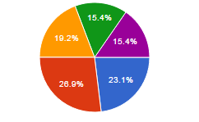
18 – 25 years |  | 23.1%
25-30 years |  | 26.9%
31-40 years |  | 19.2%
41-50 years |  | 15.4%
Over 50 years |  | 15.4%

2. What is your gender?
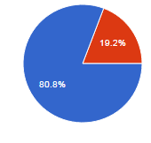
Male |  | 80.8%
Female |  | 19.2%

3. Where are you from?
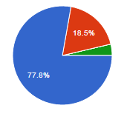
Syria |  | 77.8%
Iraq |  | 18.5%
Agfhanistan |  | 0%
Other country |  | 3.7%

4. What is the degree or level of school that you have completed?
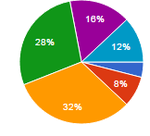
No school degree completed or it is lower than primary school |  | 4%
Primary school |  | 8%
Secondary school |  | 32%
High school |  | 28%
Vocational training |  | 16%
University degree |  | 12%
5. Where are your family members?
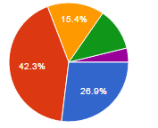
With you |  | 26.9%
In your homeland |  | 42.3%
In another European country |  | 15.4%
In a non-European country |  | 11.5%
I don’t have a family |  | 3.8%
6. Do you have a professional occupation?
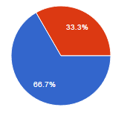
yes |  | 66.7%
no |  | 33.3%
7. What is the reason for having fled your country?
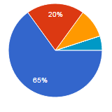
My life is exposed to dangers |  | 65%
I don’t have options for development |  | 20%
The State is not functioning |  | 10%
Educational, health care and social service systems are not functioning |  | 0%
I cannot find a job and take care of my family |  | 0%
Other reasons |  | 5%
8. Do you plan to go back to your homeland?
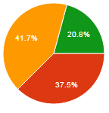
Absolutely yes |  | 0%
I will go back in case of a positive change |  | 37.5%
No, under no circumstances |  | 41.7%
I don’t know but going back remains an option |  | 20.8%
9. What is the reason for choosing the European country you are going to?
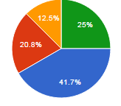
My family members are there |  | 41.7%
The social benefits matter |  | 20.8%
I can find a job there |  | 12.5%
I don’t know |  | 25%
10. Do you want to live in Bulgaria?
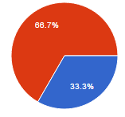
Yes |  | 33.3%
No |  | 66.7%

11. Would you like to stay in Bulgaria for a long period of time?
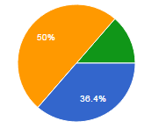
Yes, I would like to stay |  | 36.4%
Yes, if I don’t have another option |  | 0%
No, I would not stay here |  | 50%
It depends on my family and other factors |  | 13.6%
12. If you face a problem, who would you contact?
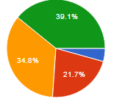
Compatriots I know |  | 4.3%
Local citizens or organizations working with refugees |  | 21.7%
State institutions |  | 34.8%
I will try to deal with the problem myself |  | 39.1%
13. Does your child study?
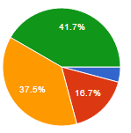
Yes, in school |  | 4.2%
Yes, in the refugee camp |  | 16.7%
No |  | 37.5%
I don’t have children and this does not concern me |  | 41.7%
14. If your child is not studying, what is the reason behind this?
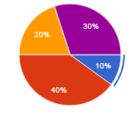
There is no profit from education and s/he doesn’t need it |  | 10%
We will move to another country |  | 40%
I fear my child is not safe |  | 20%
The other children do not accept my child because s/he is a foreigner |  | 0%
Other reasons |  | 30%
15. Do you study Bulgarian language?
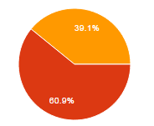

No, I don’t need to |  | 0%
No, I will move to another country |  | 60.9%
Yes, I do |  | 39.1%
16. Would you like to continue your education in the country where you would settle in?
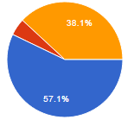
Yes |  | 57.1%
No |  | 4.8%
I will first find a job and then start studying |  | 38.1%

17. Which school level do you consider relevant and would like to complete?
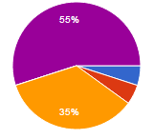

Primary school |  |  | 5%
Secondary school |  |  | 5%
High school |  |  | 35%
Vocational training |  |  | 0%
University degree |  |  | 55%
18. Would you study the language of the country you would like to settle in?
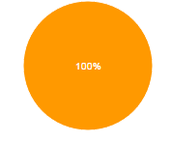
Yes, I will have language classes |  | 100%

19. What will be your main financial source in the country you would like to settle in?
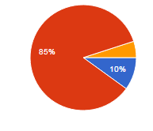
Social benefits |  | 10%
The renumeration for my labour |  | 85%
Funding from foundations and different supporting organizations |  | 5%
20. Would you like to find a job in the country where you would settle in?

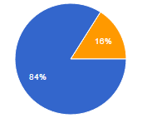

Yes |  | 84%
No |  | 0%
I don`t know |  | 16%

21. What would be your work area if you found a job?
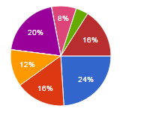
Commerce |  | 24%
Production |  | 16%
Agriculture |  | 12%
Services |  | 0%
Education |  | 20%
Banking and finance |  | 0%
Building construction |  | 8%
Transport |  | 4%
Other |  | 16%
22. What is a priority to you in finding a job?
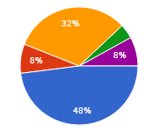

Working what I have studied for |  | 48%
Looking for a job with a higher renumeration |  | 8%
Trying to find a job as quickly as possible regardless my qualification and skills |  | 32%
Looking for any type of job regardless my qualification and skills |  | 4%
I will count on the host country to find me a job |  | 8%
I would rely on social benefits |  | 0%
23. Do you think men and women are equal and should have equal rights?
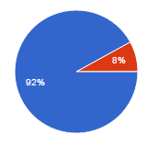
Yes |  | 92%
No |  | 8%
I don`t know |  | 0%

24. Are you familiar with the national law and customs of the host country?
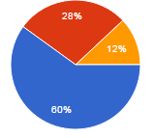

Yes |  | 60%
No |  | 28%
I don’t know much but I will get familiar once I settle there |  | 12%
I am not interested in them |  | 0%
I don’t know |  | 0%
25. Would you aim at having your own home in the host country?

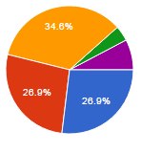
Yes, I will try to buy my own home |  | 26.9%
Yes, I will rent a home |  | 26.9%
No, I will count on the host country |  | 34.6%
No, I will go back to my homeland sooner or later |  | 3.8%
I don’t know |  | 7.7%

In parallel with the questionnaire the refugees were asked different questions regarding their decision to leave their country, or about the attitude of the Bulgarian authorities etc.
There was a group of 3 young men in their 20s, when asking how did they decide to come to Bulgaria? One guy says “I’m 24, I have not done the military service and they would arrest me, at every check point in Syria, they are asking for our ID's and anyone like me under the age of 40, they are arresting them, even the guys who already served, and once you are in the army, you can be considered as dead”. The other person agreed that it is the same reason that forced them to leave.
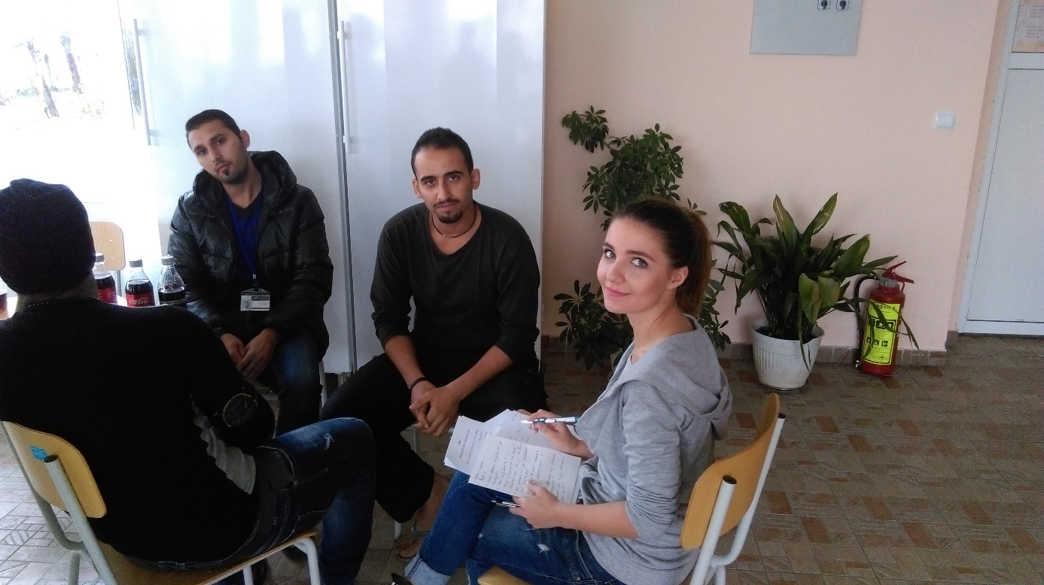
Talking with the refugees
While talking to an older man with a big family, his answer was different: “We left because there were terrorists “ISIS” near our city, we heard that they kidnap girls from surrounding cities and do terrible things to them and I did not want to wait until it happens to us. I have 3 daughters!”
The 3rd person who answered the question was a young woman with 2 little children, according to her, her city was still safe, but there was no food, medical care or electricity. “ I could not find milk for the children, or medicine when they get sick, the life was impossible there” she says.
One thing they all agree, the did not choose Bulgaria, they just decided to leave, their aim was to reach Germany. But when they cannot go to Germany directly, they go to the first country where they can find safety.
All of those refugees have crossed the border illegally with the help of smugglers, they choose Bulgaria because it is the first European country after entering Turkey and as we know Syrians do not need any document to enter Turkey apart from their ID card.
Another reason they explained is the “price”! To pay a smuggler to enter to Bulgaria is 1300 Euros says a man, and if they want to go to Germany directly it costs 5000 euros per person and they do not have that amount, especially with such big families.
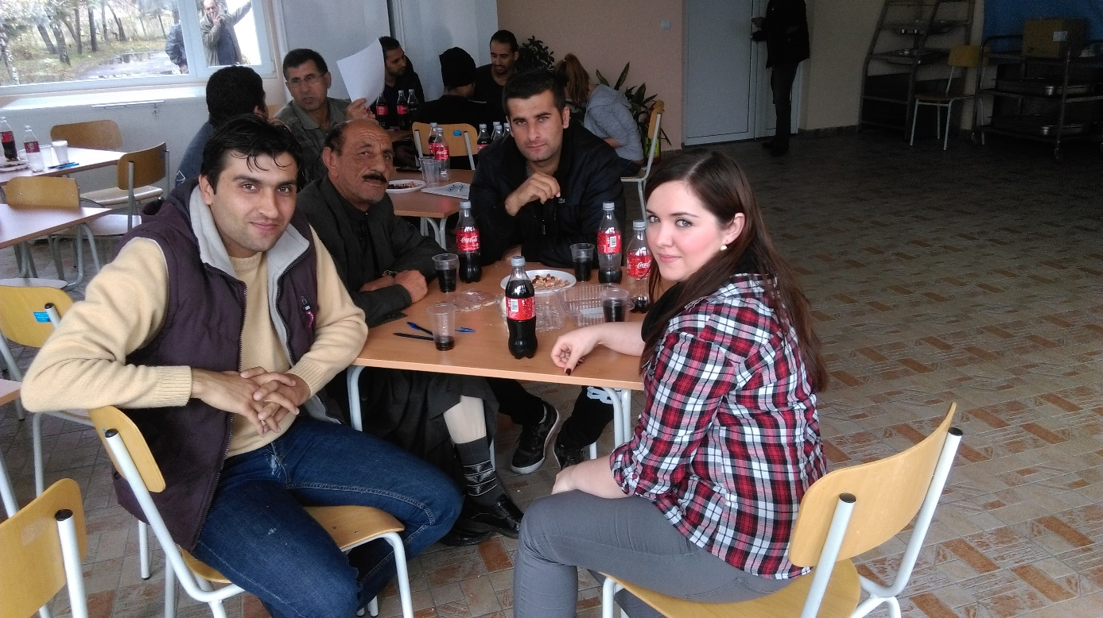
During the interview…
Three men who came about 8 months ago confirm that they came by foot and person accompanied them until they reached near the border then he disappeared. While a family who came more recently says that they came by car “when we came it was easier, we walked by foot for 4 hours in the forest, then a car came to pick us, it took us less than one day to arrive”.
Unfortunately, this is not everyone's story, a guy tells that he spent 4 days in the forest, he was stopped the first time by the police on the border and asked to go back, only the second time he managed to enter, “Although we were hungry and exhausted, they did not treat me softer” the police” , There was even a woman with us, we were in the same group, she was crying a lot and the officer was shouting on her. We waited for about 7 hours that day, there was no translator, they did not bring us any food, we were just sitting outside as they did not let us enter, and we were waiting for help until it was around 06 pm, they managed to bring a translator to talk to us”.
Among the women I talked with, only one lady from Iraq was a teacher, the rest never worked. As per the men we met, they used to work in Syria in agricultural work or small private mini markets, there was also a tailor, and a teacher.
Almost 100% of the refugees are not planning to stay and make a life in Bulgaria. Their main reasons are: first, the material support they receive in other countries, especially in Germany, including home, monthly salary, free language courses and job offers.
The second main reason is that many of them already have part of their family living in Germany, and this will help them to adapt faster.
Their main complaints in Bulgaria beside the lack of material support are that there are no programs to support integration, or free Bulgarian language courses. They do not have any serious complains from Bulgarian people as a society but they have many of the governmental support. “The main problem are my children, they sit doing nothing instead of being at school and 10 months passed already since we are waiting for documents” says a woman in her mid-30s.
In general, the problems in Bulgaria are can be summarized in lack of money, language barrier, and troubles and delays in receiving the documents that permit them to study, work, and travel.
Only a few of them are planning to stay in Bulgaria. On of such persons was a man in his 40s, who wanted to bring his family here and work as truck drivers.
There were also 2 young boys between 18-27 years of age, who have already started work here in Sofia and would happily stay, finish their education and learn the language. They`re both from Iraq, and they work in a call center with English and Arabic, back in their hometown in Iraq they were in their second year of I.T. studies. Unlike the first two men they`re seeking a better future and opportunities for development.
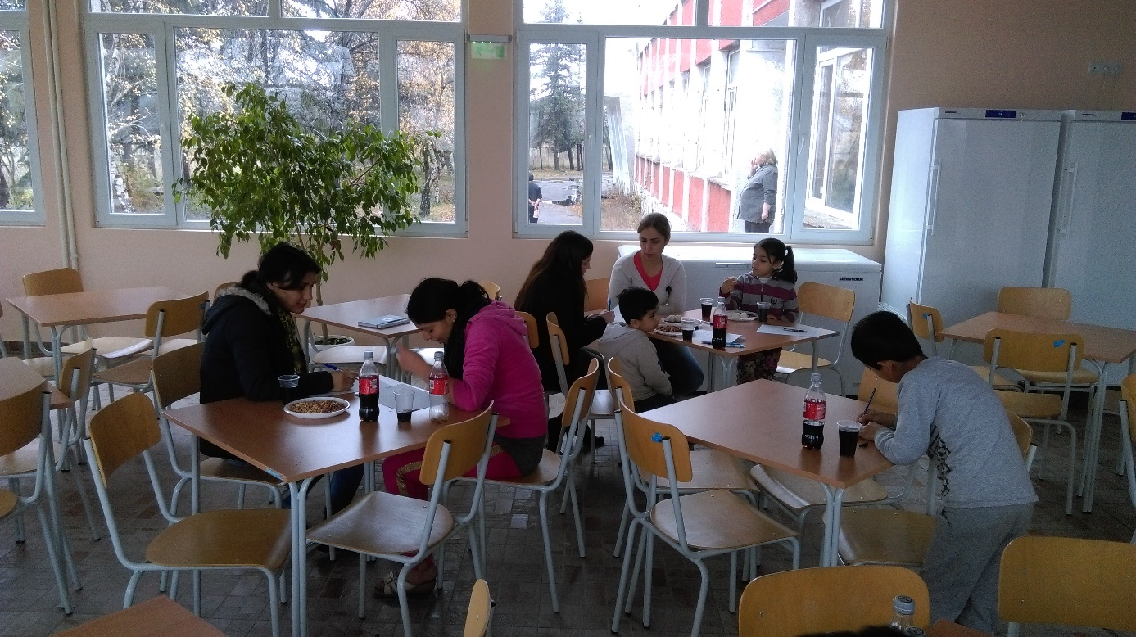
There are very few women among the refugees.
The majority of the refugees see Bulgaria as “the door to Western Europe”-Germany in particular.
The small group of women we managed to talk to, were of Kurdish origin lacking basic education.
The main reason for this great disproportion between the numbers of men and women is the fact that most men are not willing to get involved into such a risk, by undertaking this dangerous journey led by smugglers together with their families, they would rather find a legal way to reunite later. Once they cross the border, they say— empty-handed and in a foreign land, it`s in their best interest to be alone during this period of rebuilding your life from zero, because the faster you integrate the sooner you`ll have your family in a safe and healthy environment.

Attitudes of Bulgarian people towards integration of refugees.

The questionnaire does not feature the indicators related to the last policy area (“welcoming society”).

